**Census Tracts and Boundary Criteria**

According to [Chapter 10: Census Tracts and Block Numbering Areas](https://www2.census.gov/geo/pdfs/reference/GARM/Ch10GARM.pdf) of the Census Bureau’s [Geographic Areas Reference Manual](https://www.census.gov/programs-surveys/geography/guidance/geographic-areas-reference-manual.html), census tracts are geographic areas within counties that the Census Bureau uses to “collect, organize, tabulate, and present the results of its decennial censuses.” (p. 10-1) Local committees of data users delineate census tract boundaries based on a set of standards developed over time by a close collaboration between the Census Bureau and census statistical area committees. The Census Bureau does not mandate these standards, however, the standards are well established and continue to guide the establishment and revision of census tracts. (p. 10-4)

The Census Bureau identifies several criteria for delineating Census tracts, and each criterion fitts into one of three broader areas: boundary, demographics, and identification. Census tracts are small relative to counties and many municipalities. They vary in physical area to accommodate the boundary and demographic criteria outlined below.

**Boundary: permanence and visibility.** Census tract boundaries “generally follow permanent, visible features, such as streets, roads, highways, rivers, canals, railroads, and high-tension power lines.” (p. 10-5) The most important of these two criteria is visibility. Tract boundaries must be “readily identifiable in the field.” (p. 10-6) Census tracts are required to follow county boundaries, i.e., they are nested within counties, but they are not required to follow municipal, voting district, school district, or any other geographic boundaries established by the Census Bureau to tabulate and publish data. (p. 13, 15-16) The [*Standard Hierarchy of Census Geographic Entities*](https://www2.census.gov/geo/pdfs/reference/geodiagram.pdf?)diagram illustrates how the various census geographies relate to one another(see [Hierarchy Diagrams](https://www.census.gov/programs-surveys/geography/guidance/hierarchy.html) for more information about the diagram).

**Demographics: population, housing, and socioeconomic characteristics.** When first establishing census tracts, the Census Bureau recommends that the average population for all tracts in a county be about 4,000 people, which is about 1,500 housing units. The population for any individual tract should be between 2,500 and 8,000 people, which is about 1,000 - 3,000 housing units. Also, the Census Bureau recommends each tract to be homogenous with respect to housing and socioeconomic characteristics. Over time, these characteristics will change and a given tract will become less homogenous, however, in the beginning similarity in housing and socioeconomic characteristics is standard. (p. 10-6)

**Identification: numbering.** The Census Bureau establishes conventions for numbering tracts. Tracts are numbered instead of named for better management of tract changes and to facilitate analysis. The Census Bureau sometimes recommends numeric ranges for a census statistical area committee to follow to ensure tract numbers are not the same as those in a bordering county. The established conventions promote consistency and constancy in numbering, which facilitates intercensal comparisons. (p. 10-7)

Tract numbers are limited to four digits with an optional two-digit decimal extension.

**Census Tracts and 2000-2010 Relationships**

According to a presentation file available from the Census Bureau, [CensusTracts.pdf](https://www2.census.gov/geo/pdfs/education/CensusTracts.pdf), “Census tracts are split or merged, depending on population change.” (slide 7)

A tract is split into two or more tracts when the population exceeds 8,000 people. The tracts that result from a split are numbered with the same four-digit number as the original tract with an additional two-digit extension to distinguish among them. For example, if hypothetical tract 999 were split into three tracts, they would be named 999.01, 999.02, and 999.03. (slide 8)

A tract is merged with an adjacent tract when the population drops below 1,200 people. The resulting track is given a new number. (slide 8)

A tract can also be revised by making small modifications to its boundary. This involves either transferring a portion of its area to an adjacent track or incorporating a portion of an adjacent track into its boundary. (slide 8)

All track changes are documented in a relationship file for reference in a decennial analysis.

**The Relationship File**

The Allegheny County 2000-2010 Census Tract Relationship File shows how 2010 Census tracts in Allegheny County, Pennsylvania relate to the 2000 Census tracts. Each record (row) consists of one unique relationship between a 2000 Census tract/2010 Census tract spatial set where a spatial set is the unique area shared by the record’s 2000 and 2010 tracts. Changes in tracts involve area, land area, population, and/or housing unit counts. Specifically, each record specifies the area, land area, population, and housing unit counts that were transferred to the record’s 2010 tract (TRACT10) from the record’s 2000 tract. The 2000 area (AREA00), land area (AREALAND00), population (POP00), and housing unit count (HU00) for the record is the standardized 2010 value for the record’s 2000 tract (TRACT00). These are the values to use when comparing 2010 population and housing unit counts to those values in the 2000 Census for a particular tract.

**Visualize Tract Changes**

The relationship file can be used with Census tract TIGER shape files to visualize the 2000 to 2010 changes for a particular tract. For tract 402, the figures below show the 2000 Census boundary (Figure 1), the 2010 Census boundary (Figure 2), and the shared areas as the 2010 boundaries overlay the 2000 Census boundaries (Figure 3).

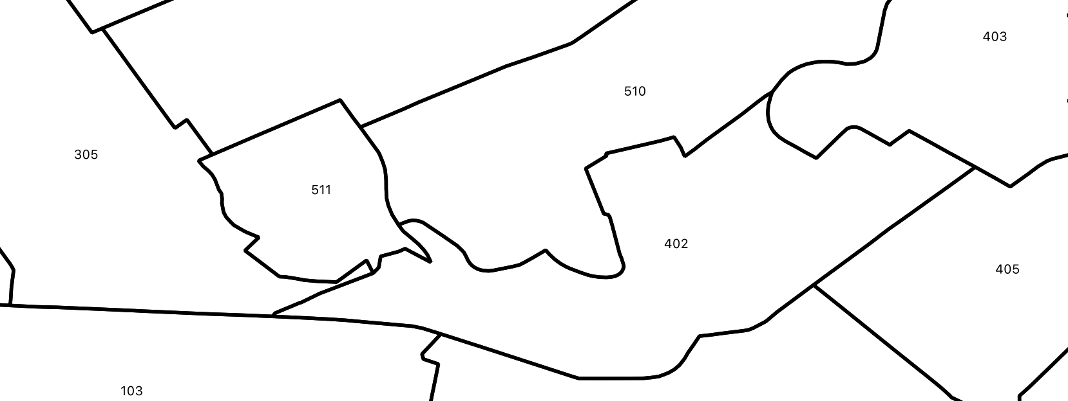

Figure 1: Tract 402 Boundary for the 2000 Census

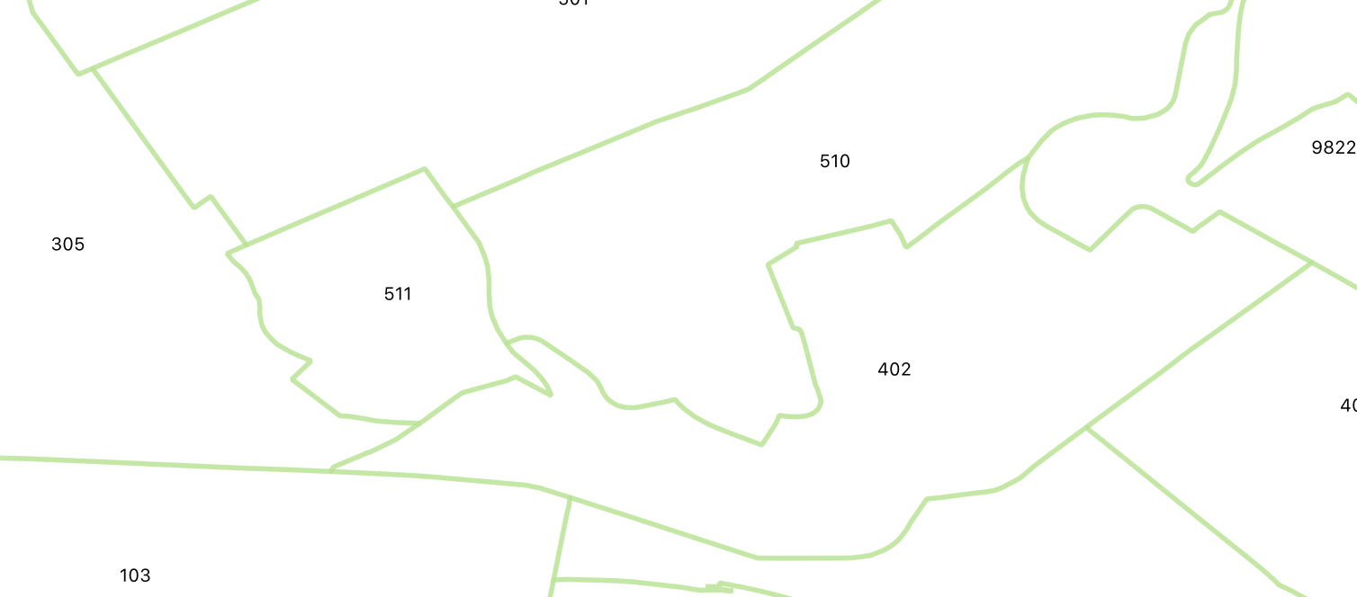

Figure 2: Tract 402 Boudary for the 2010 Census

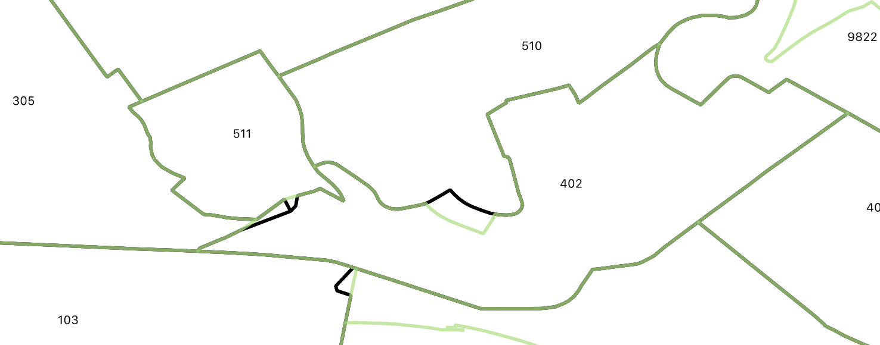

Figure 3: Tract 402 Shared Area Between the 2000 and 2010 Censuses

In Figure 3 above, the dark green line indicates boundary lines that did not change between the two Censuses. The black line indicates boundaries unique to 2000, and the light green line indicates boundaries unique to 2010.

The file *Tract 402 Area Changes Illustrated.pdf* uses tract 402 to illustrate how each relationship file record corresponds to a unique tract boundary change. The image file *2000-2010Tracts.png* shows all tracts in Allegheny County with the 2010 Census tracts overlaying the 2000 Census tracts. The boundary lines for these two files are marked with the same colors as those used in Figure 3 above.